**Ansible Installation**



Pre-requisites :-

- two vm u must have with rhel 8 installed and yum should be configured in it

As in my case I am using two rhel 8 vm having ip system 1 - **192.168.43.178 (Ansible INstalled in this vm)**and one more vm I used having ip system 2 - **192.168.43.247 (Used for performing output of ansible tool means here I installed firefox using ansible from system 1 )**

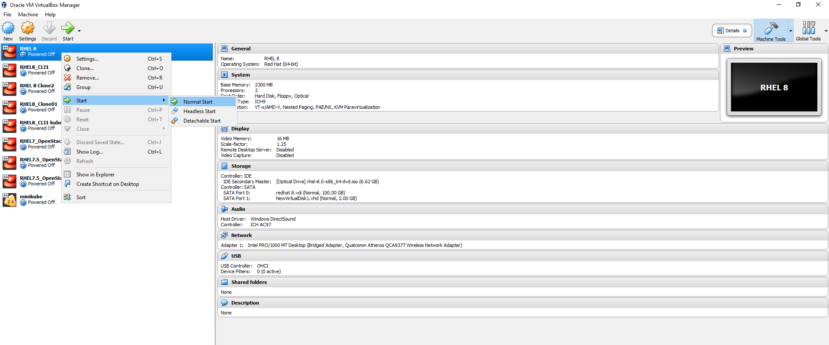

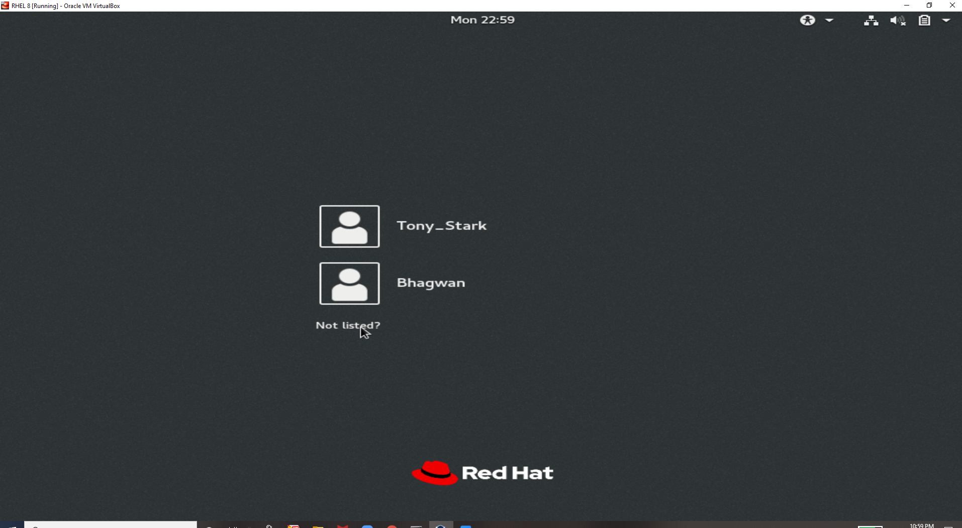

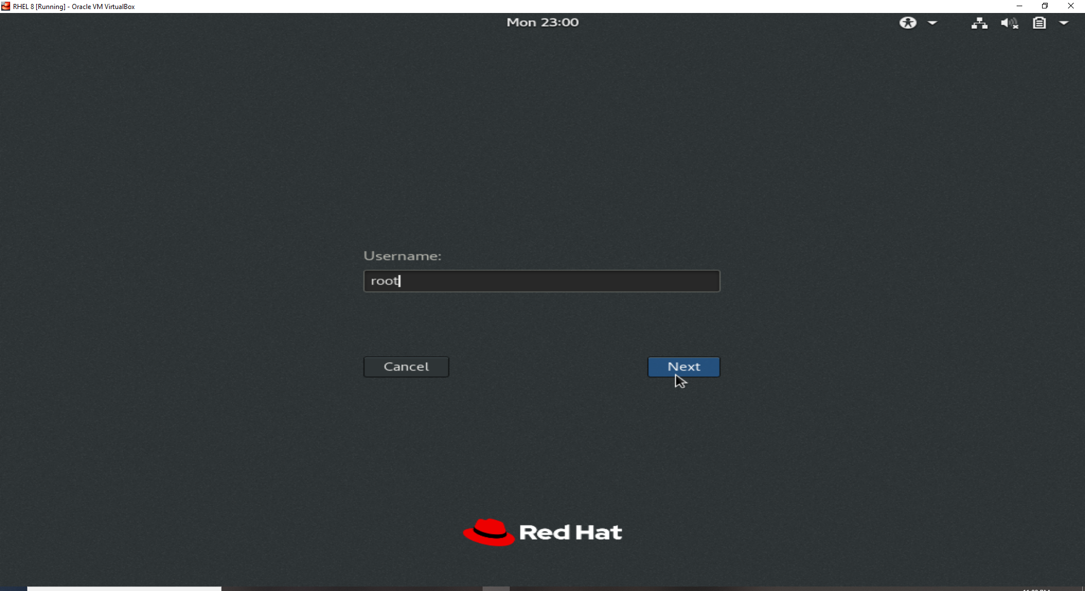

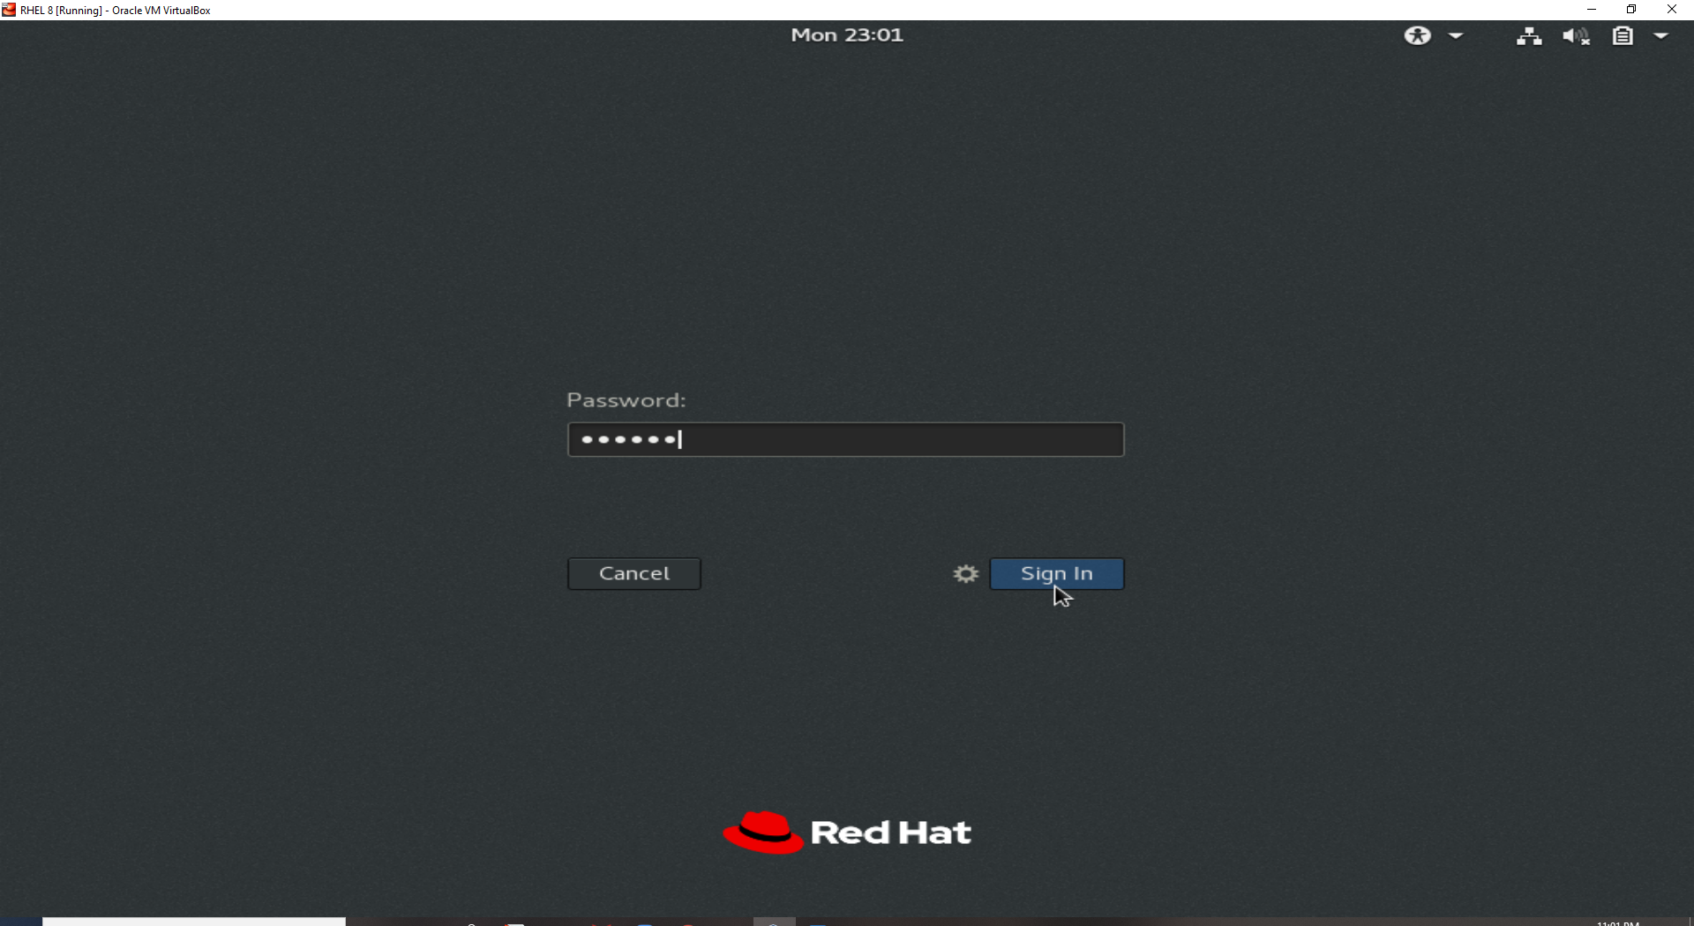

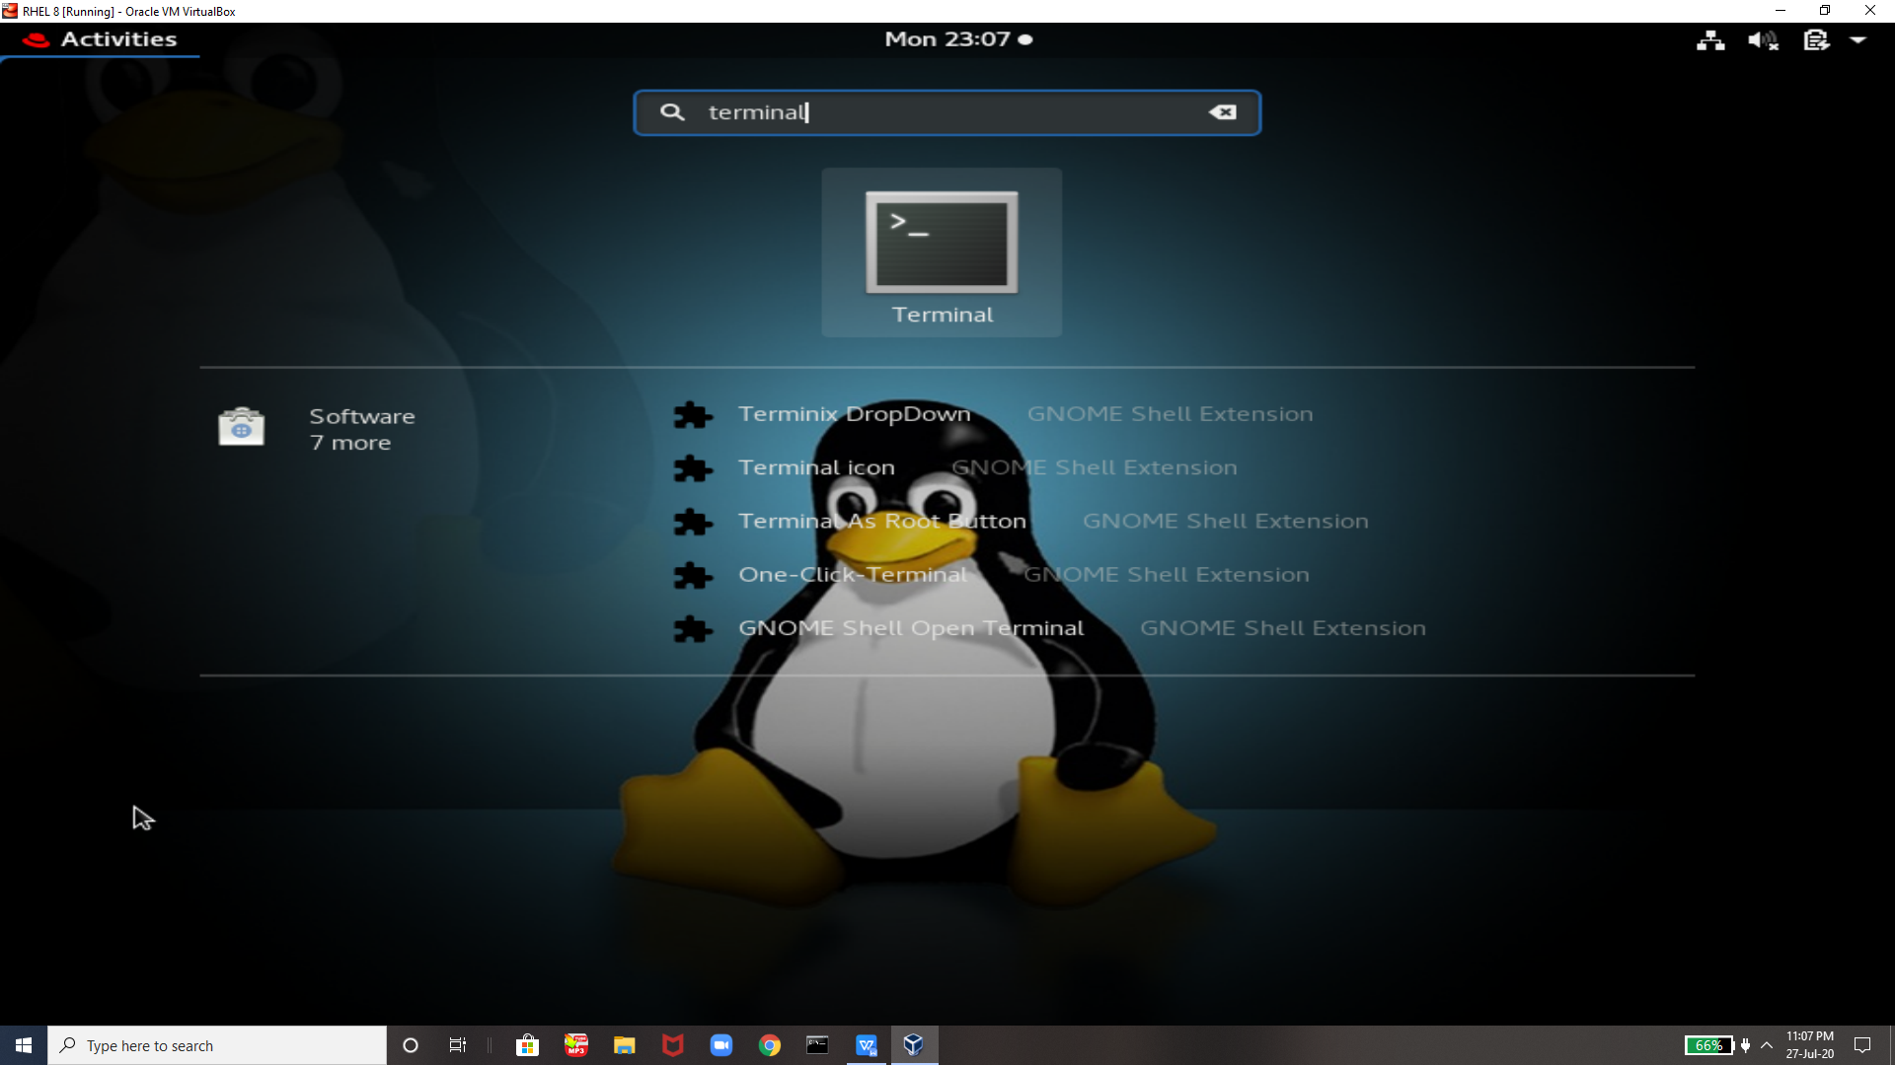

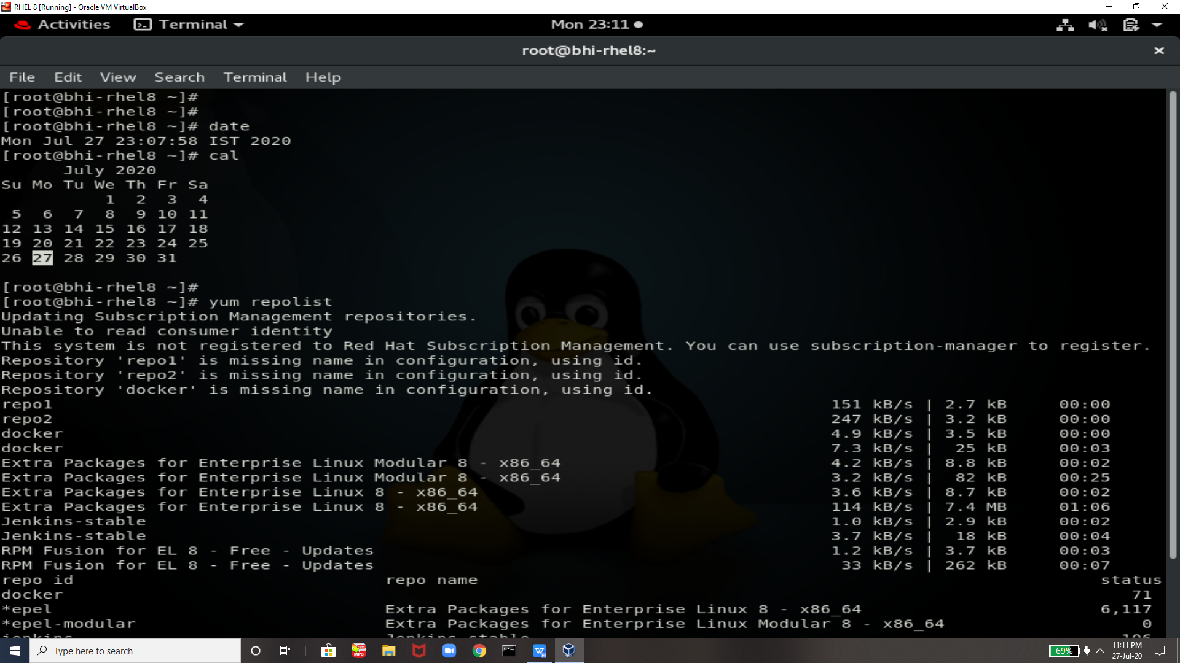

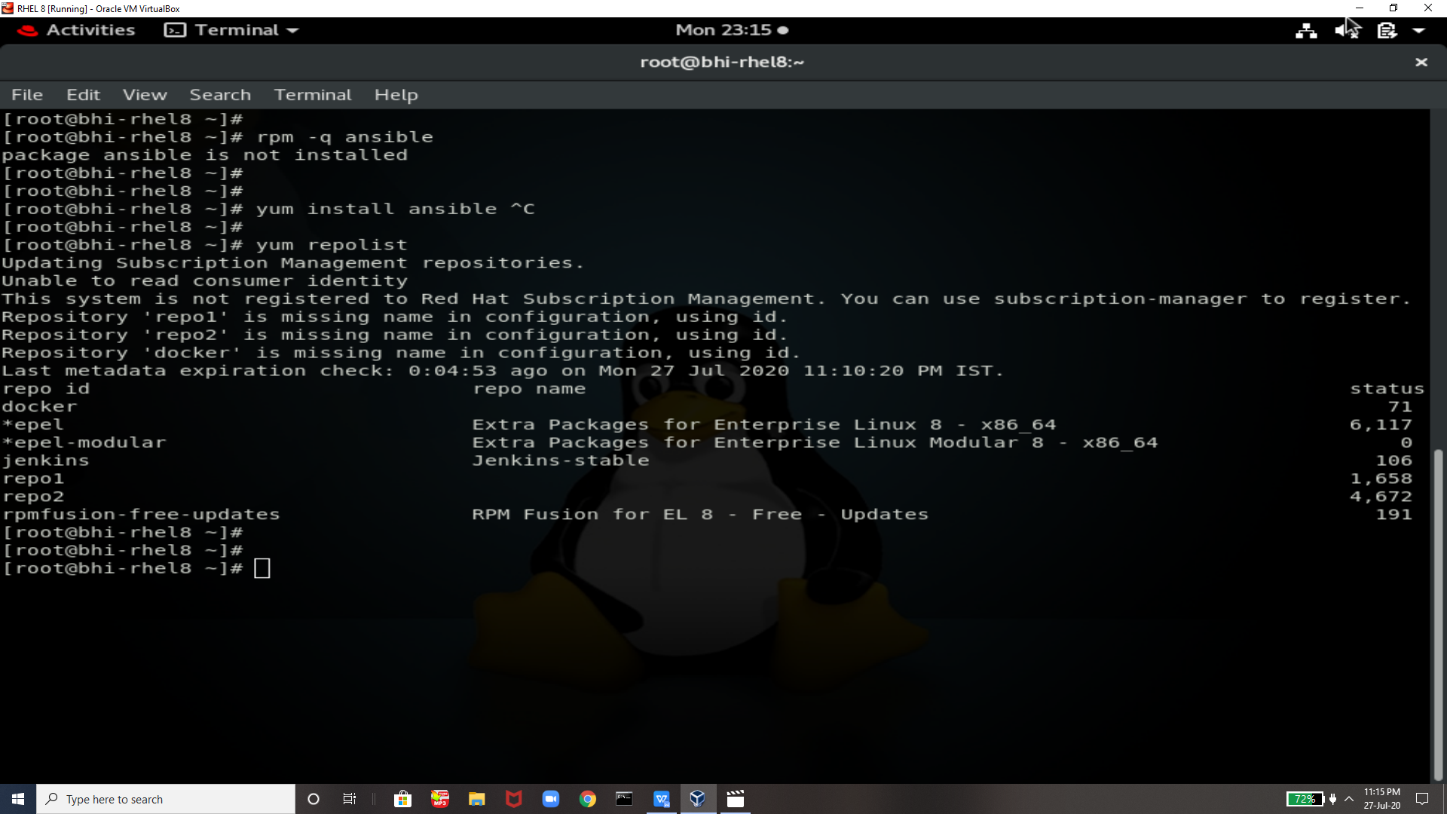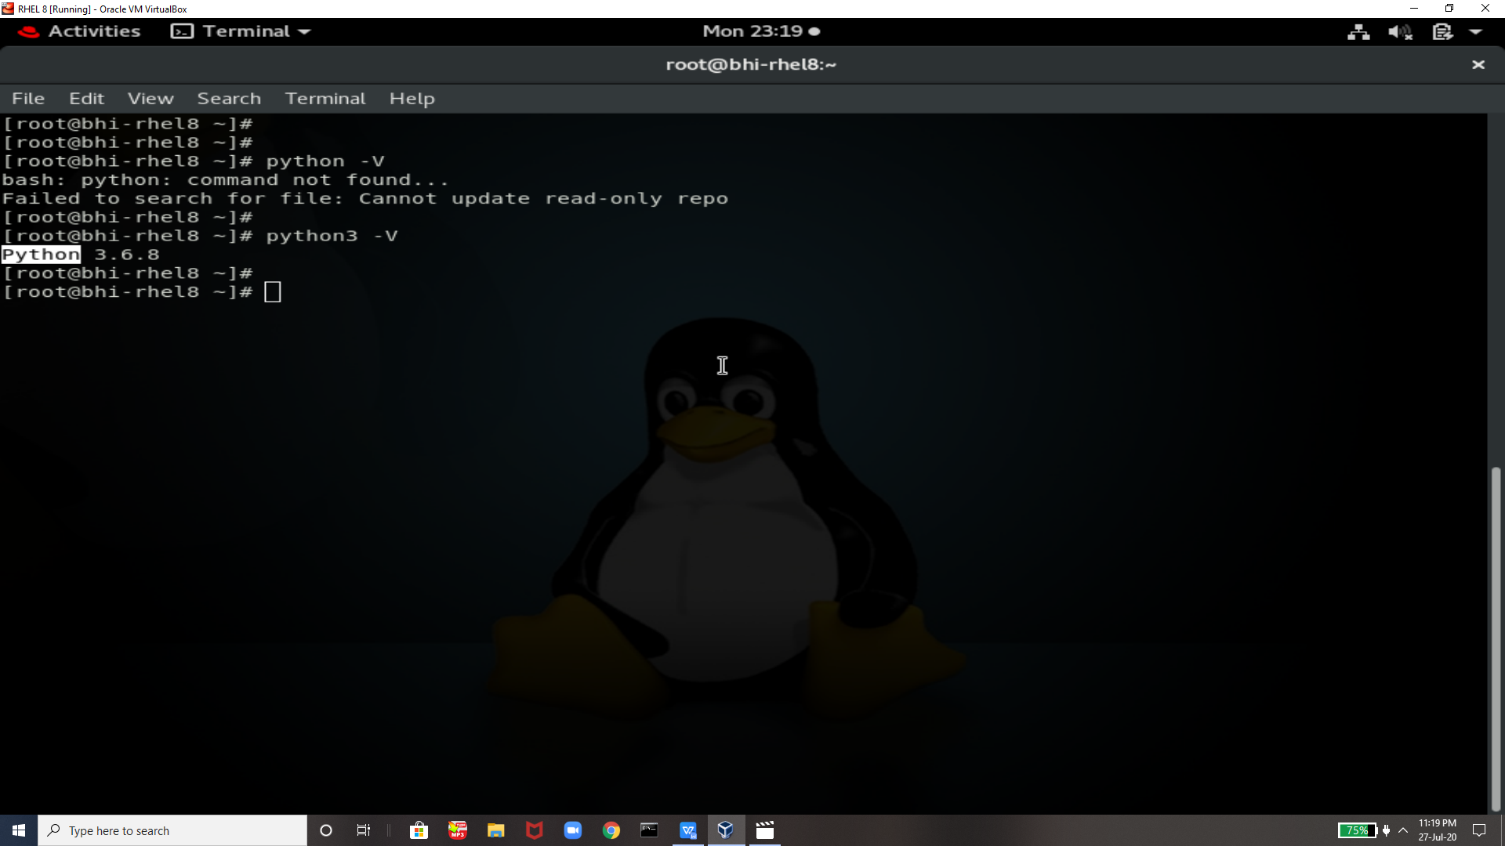

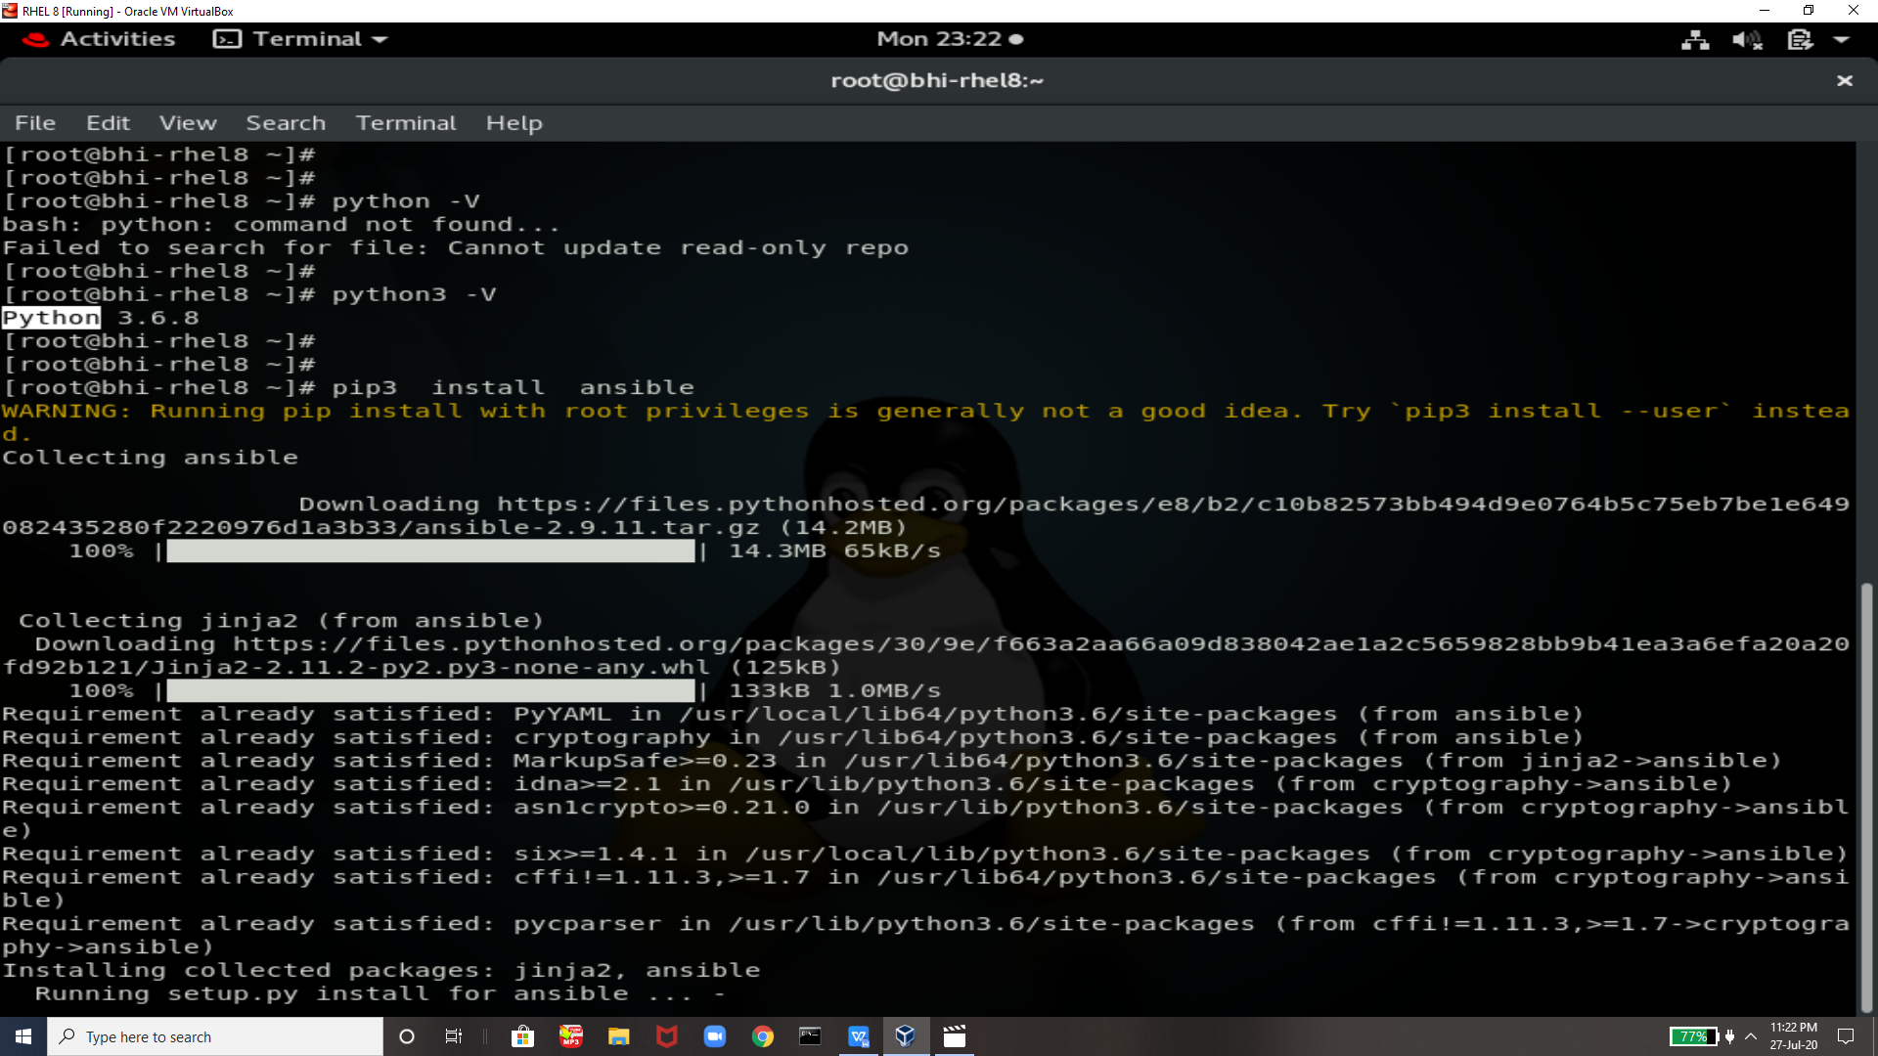

Now Ansible is Successfully Installed

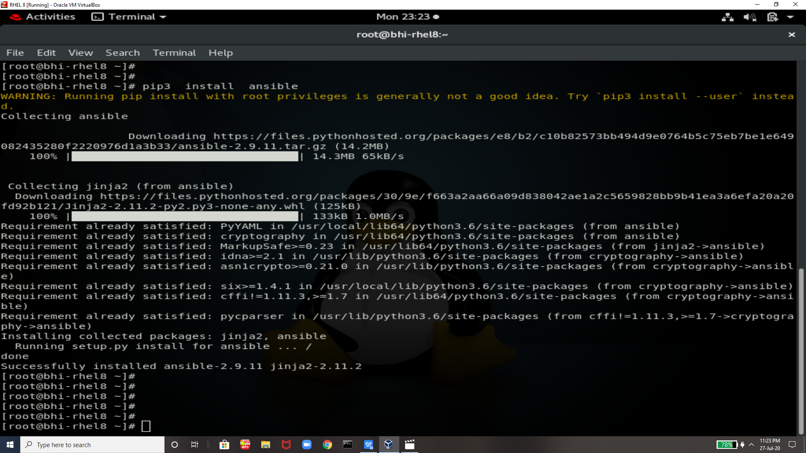

IP of System

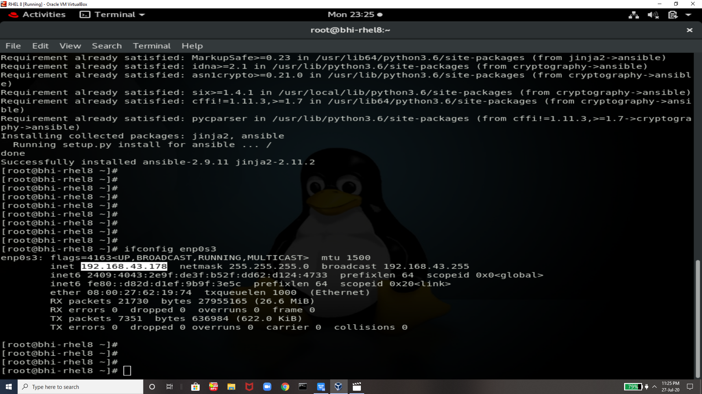

Checking Ansible Details

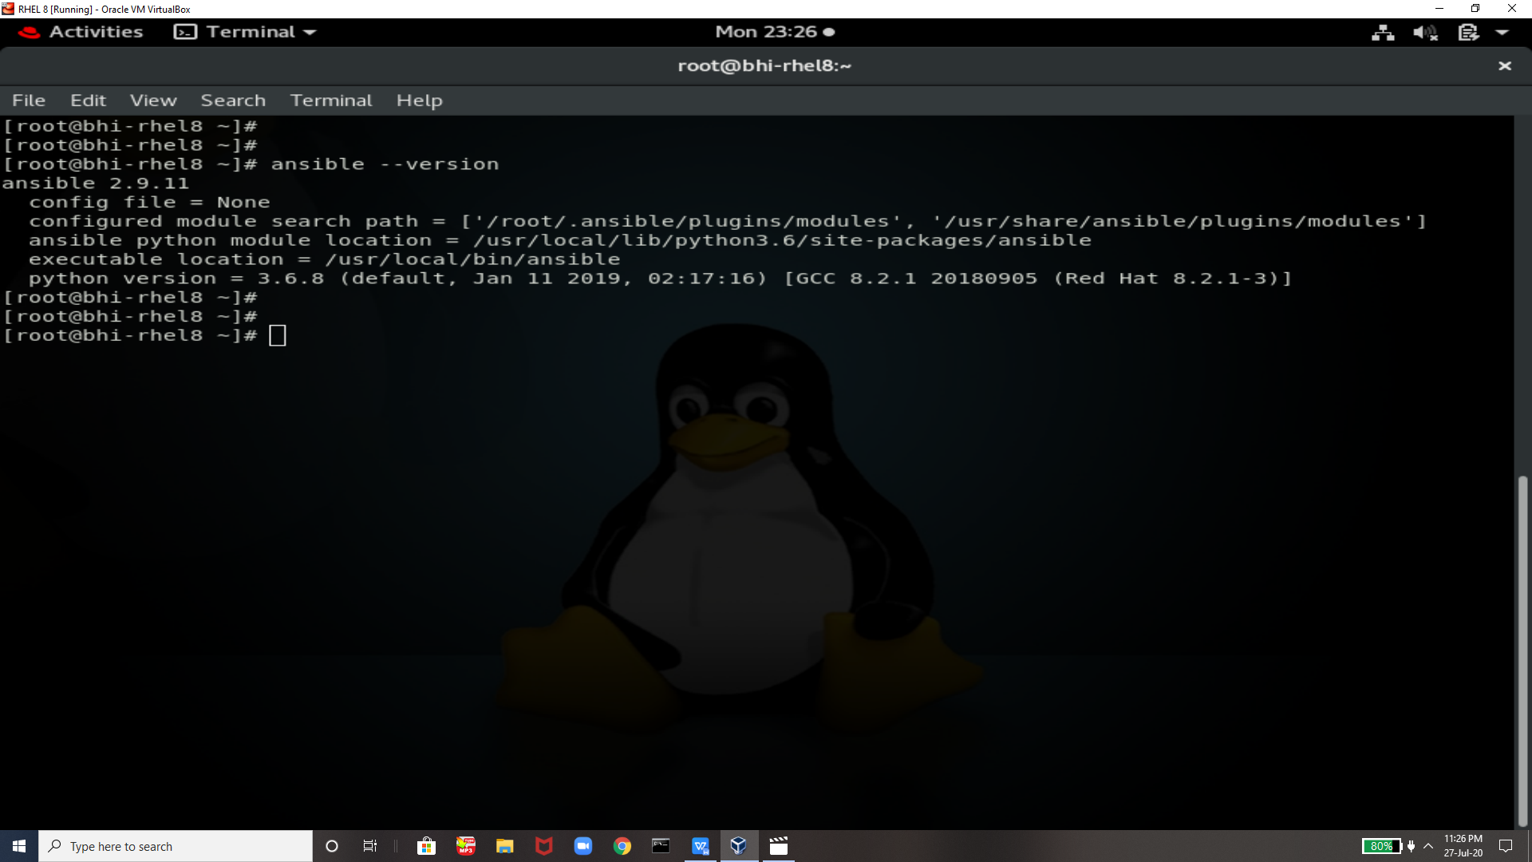

Cheking host list available

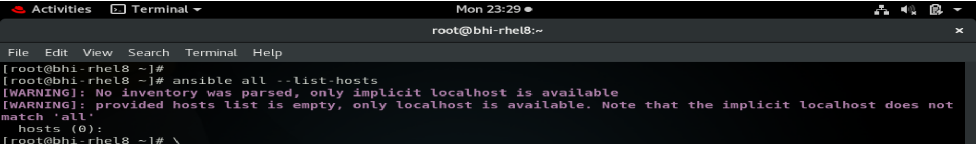

Actually here I changed my vm so ip will be **192.168.43.247** 

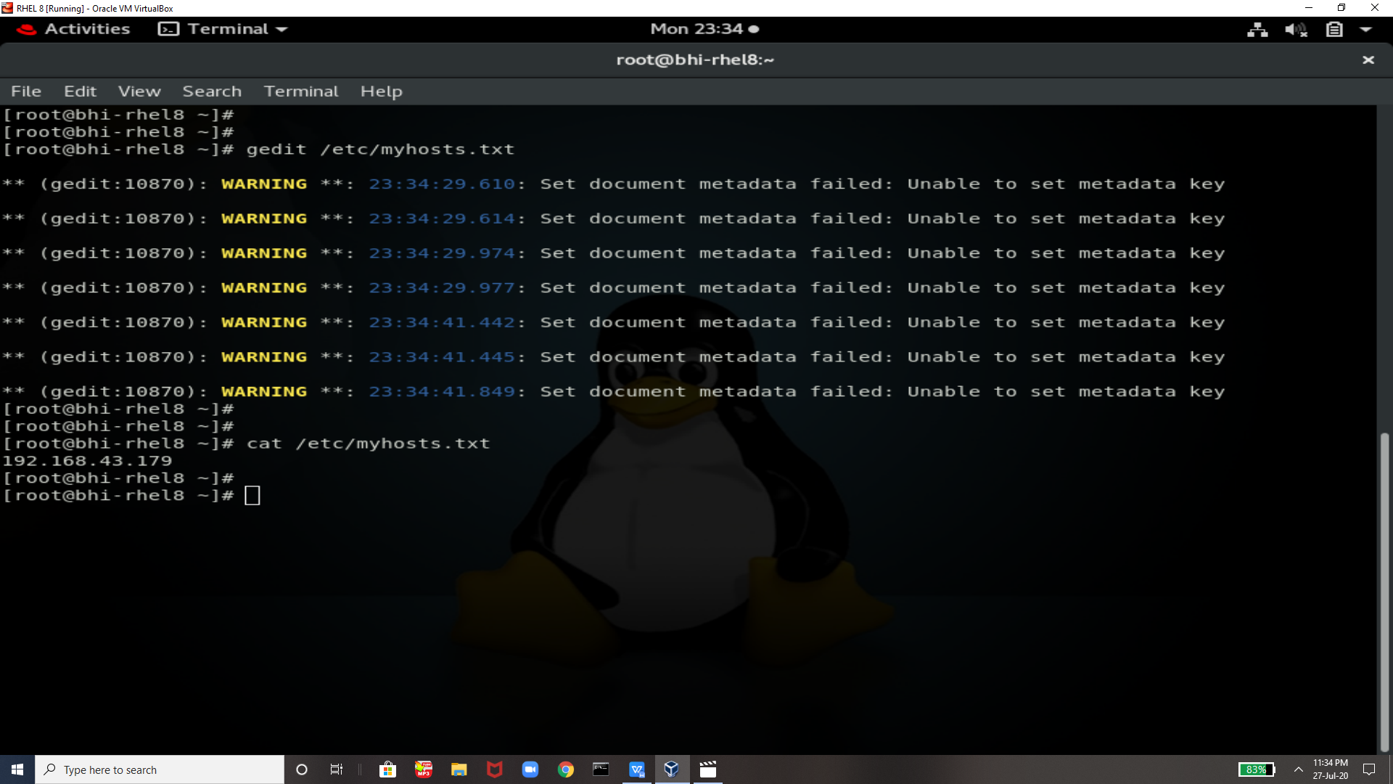

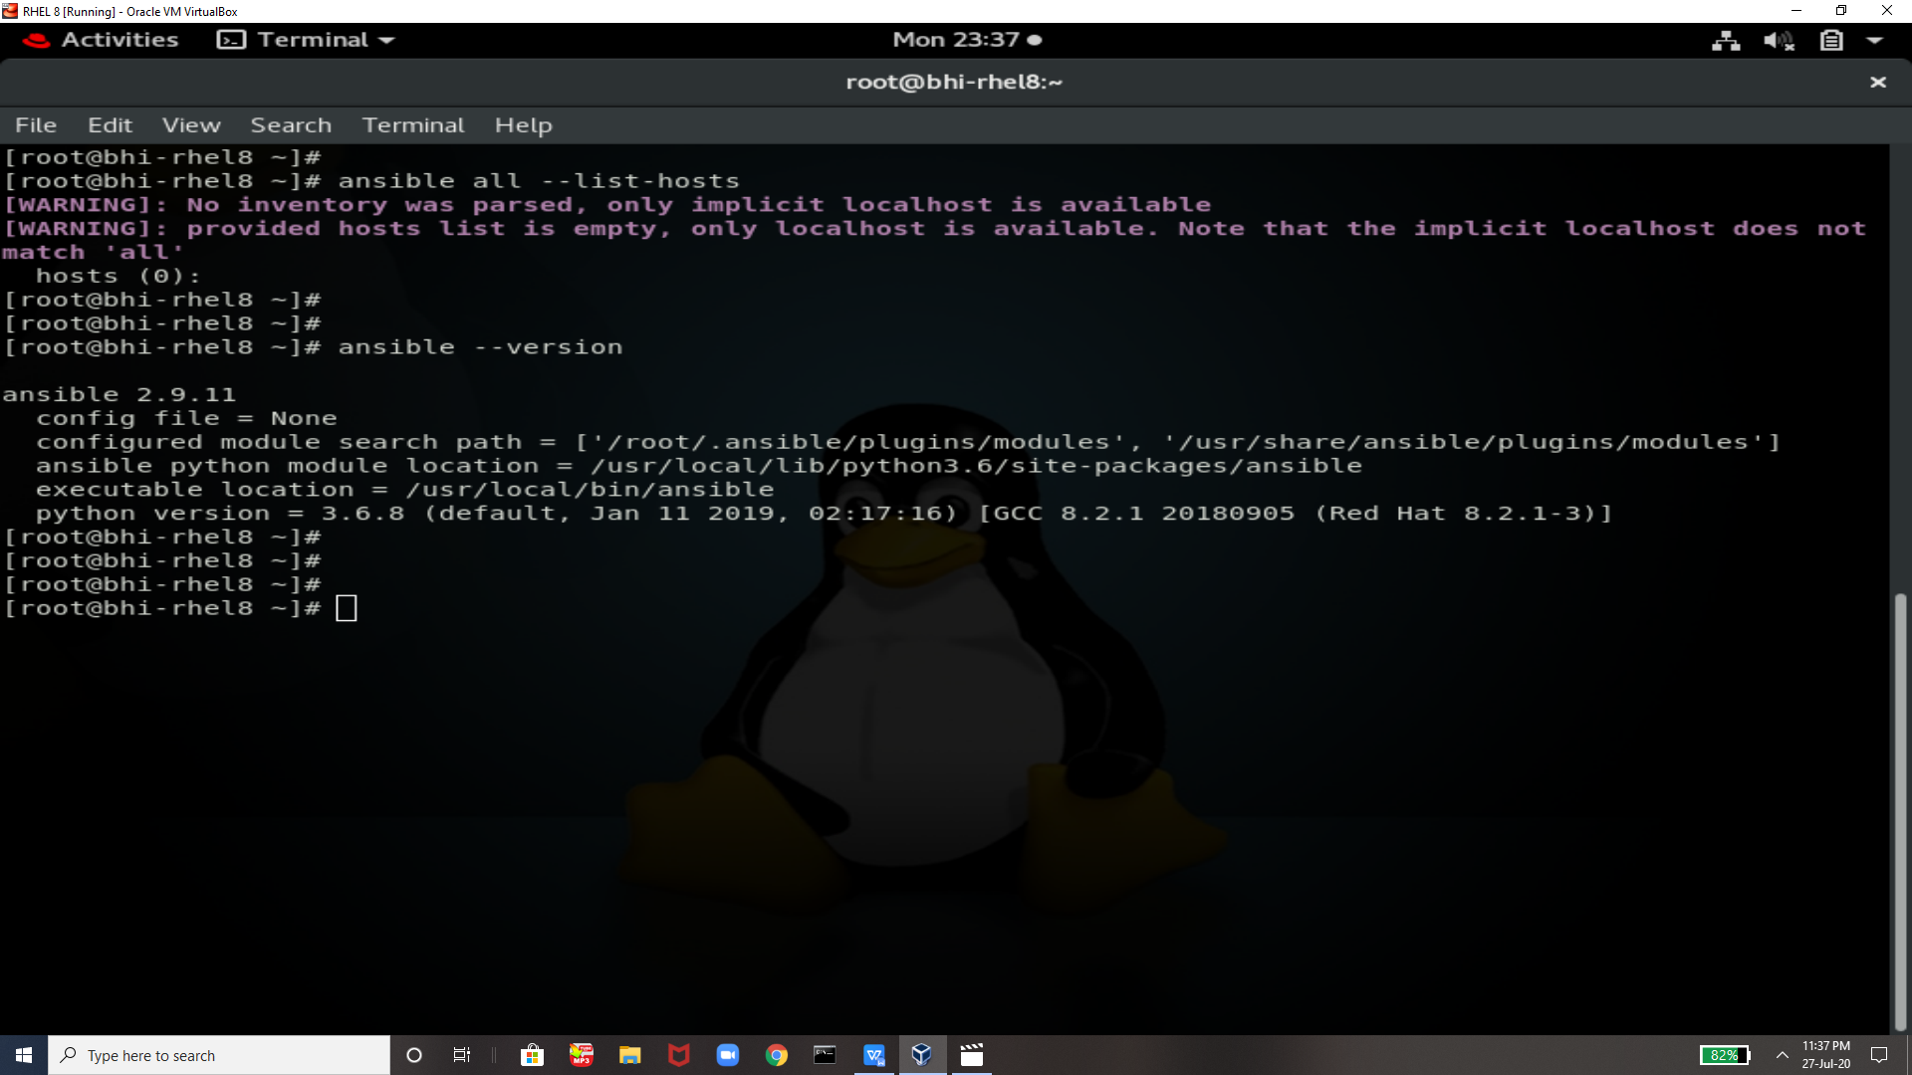

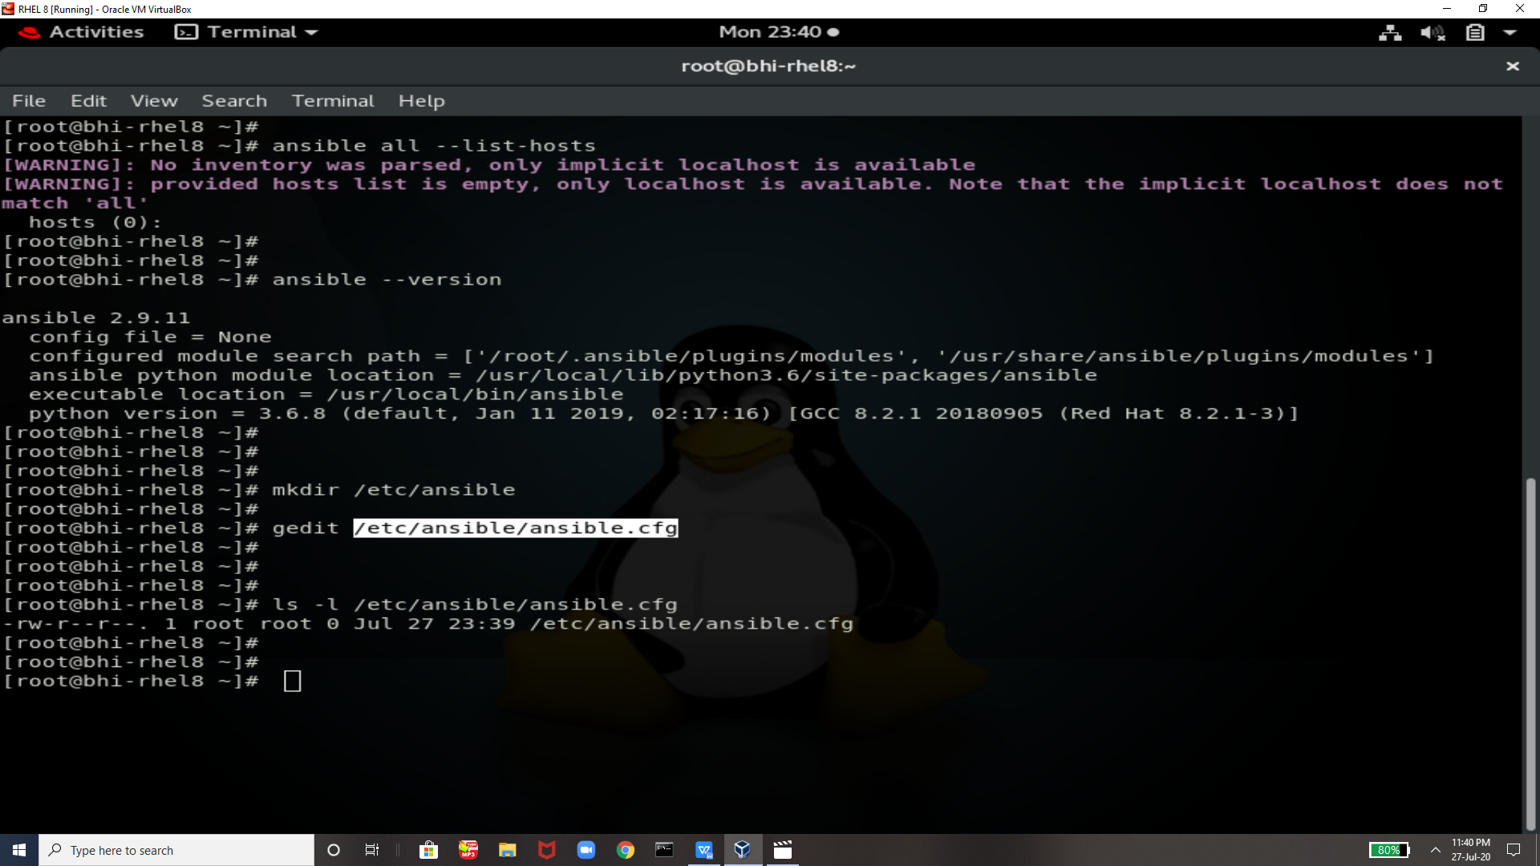

Copying the file name and pasting in cfg file

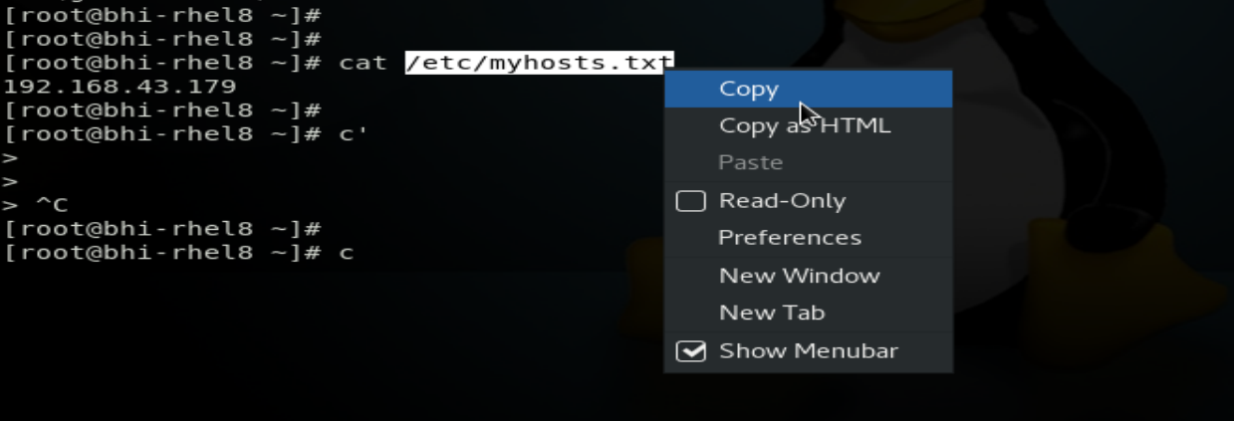

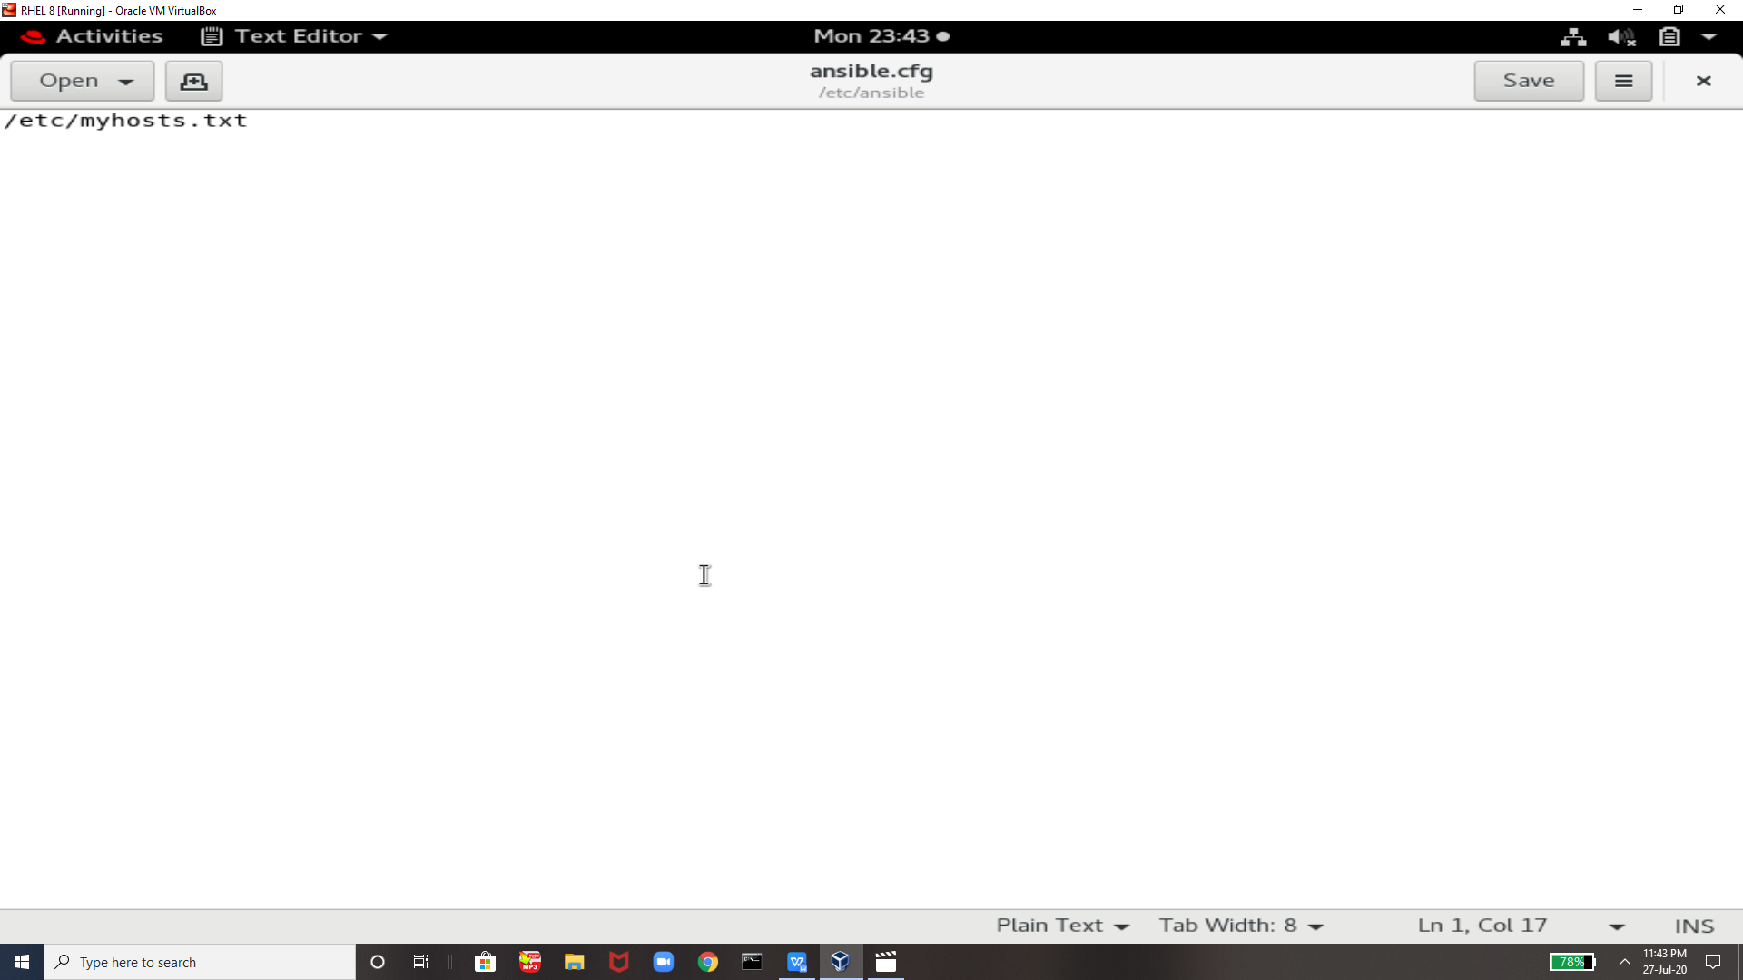

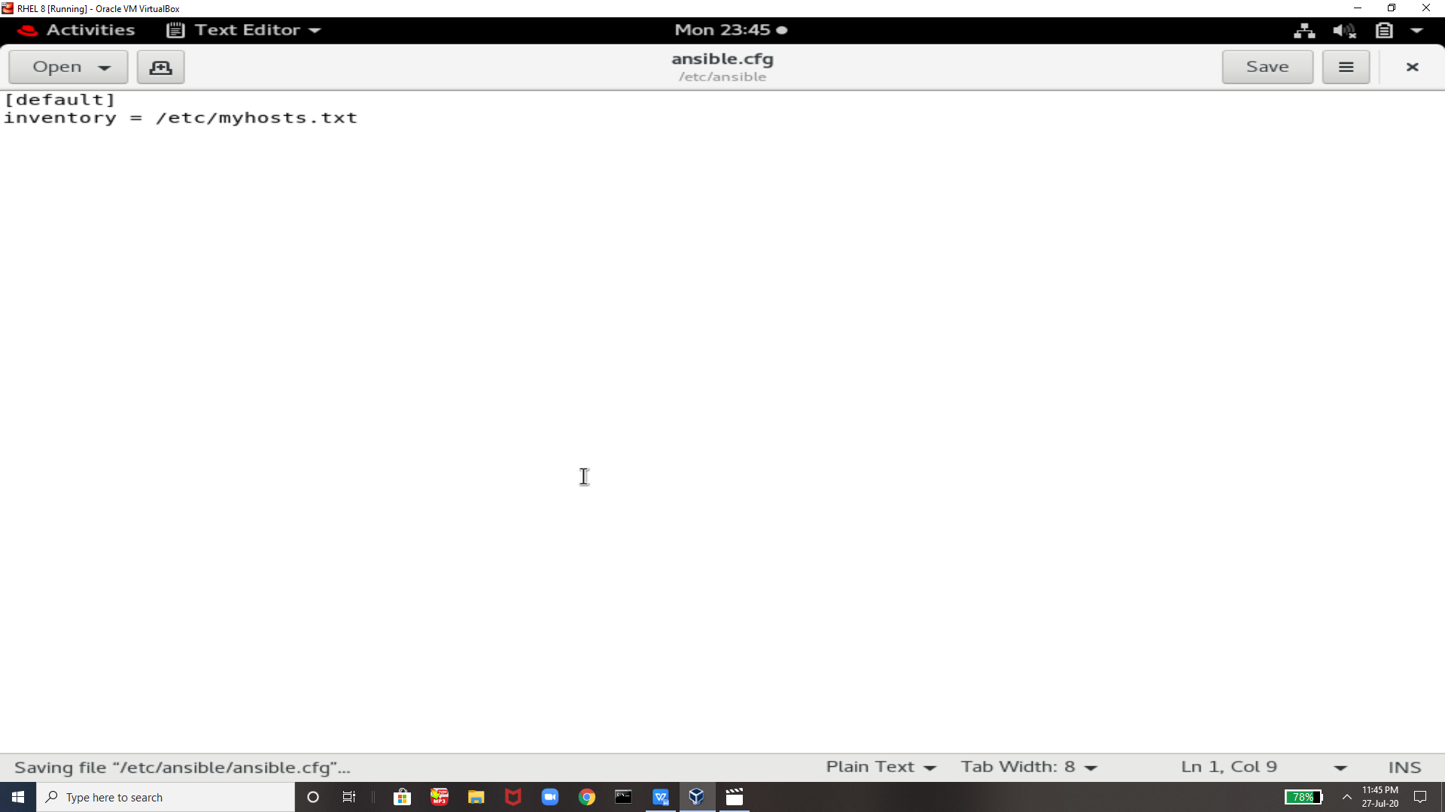

Installing sshpass

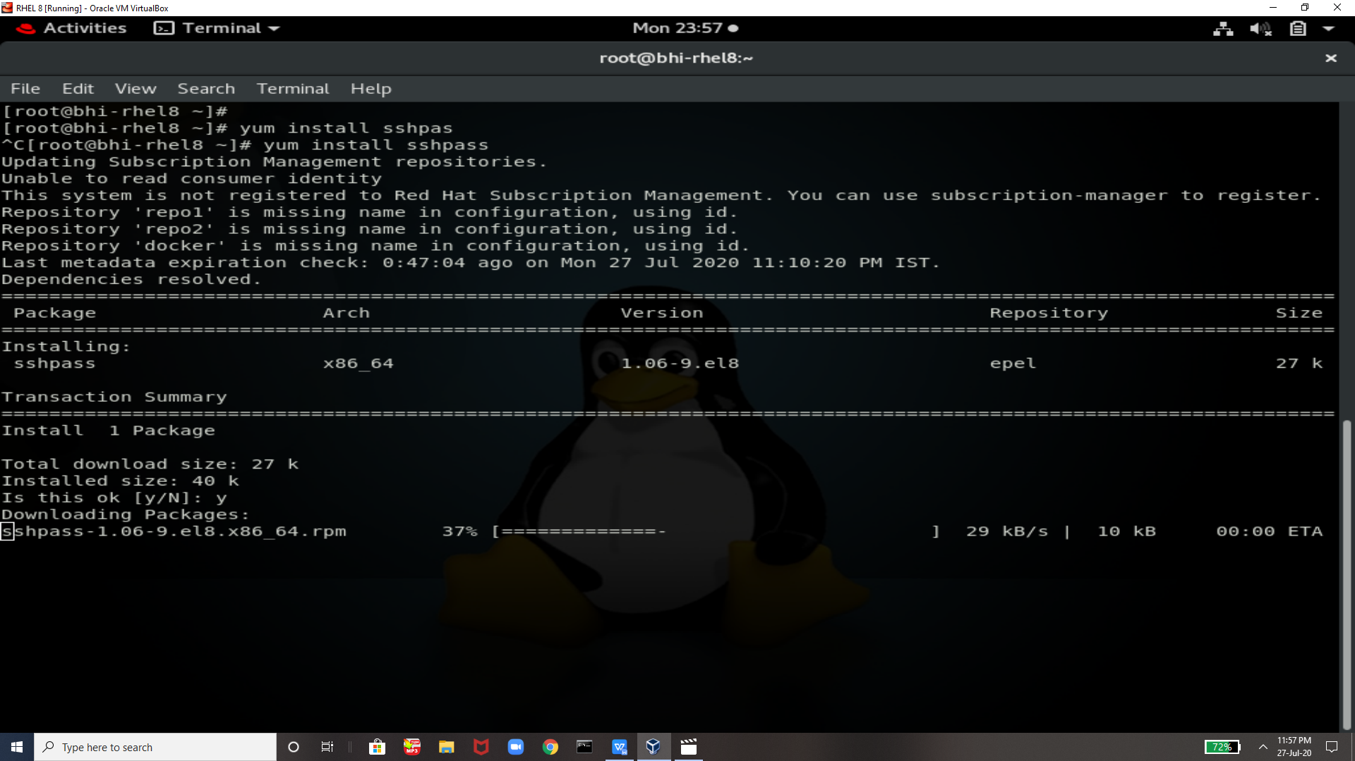

Sshpass is installed successfully

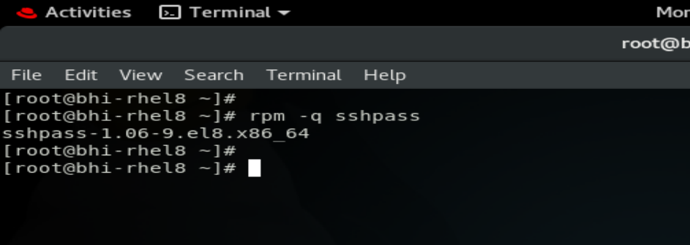

Starting Another machine so that we can persorm our work

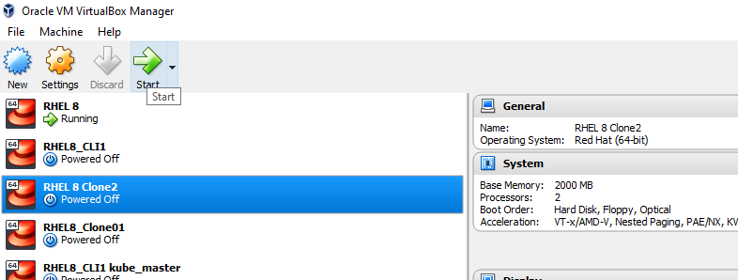

Similiary as previous we are starting a new rhel 8

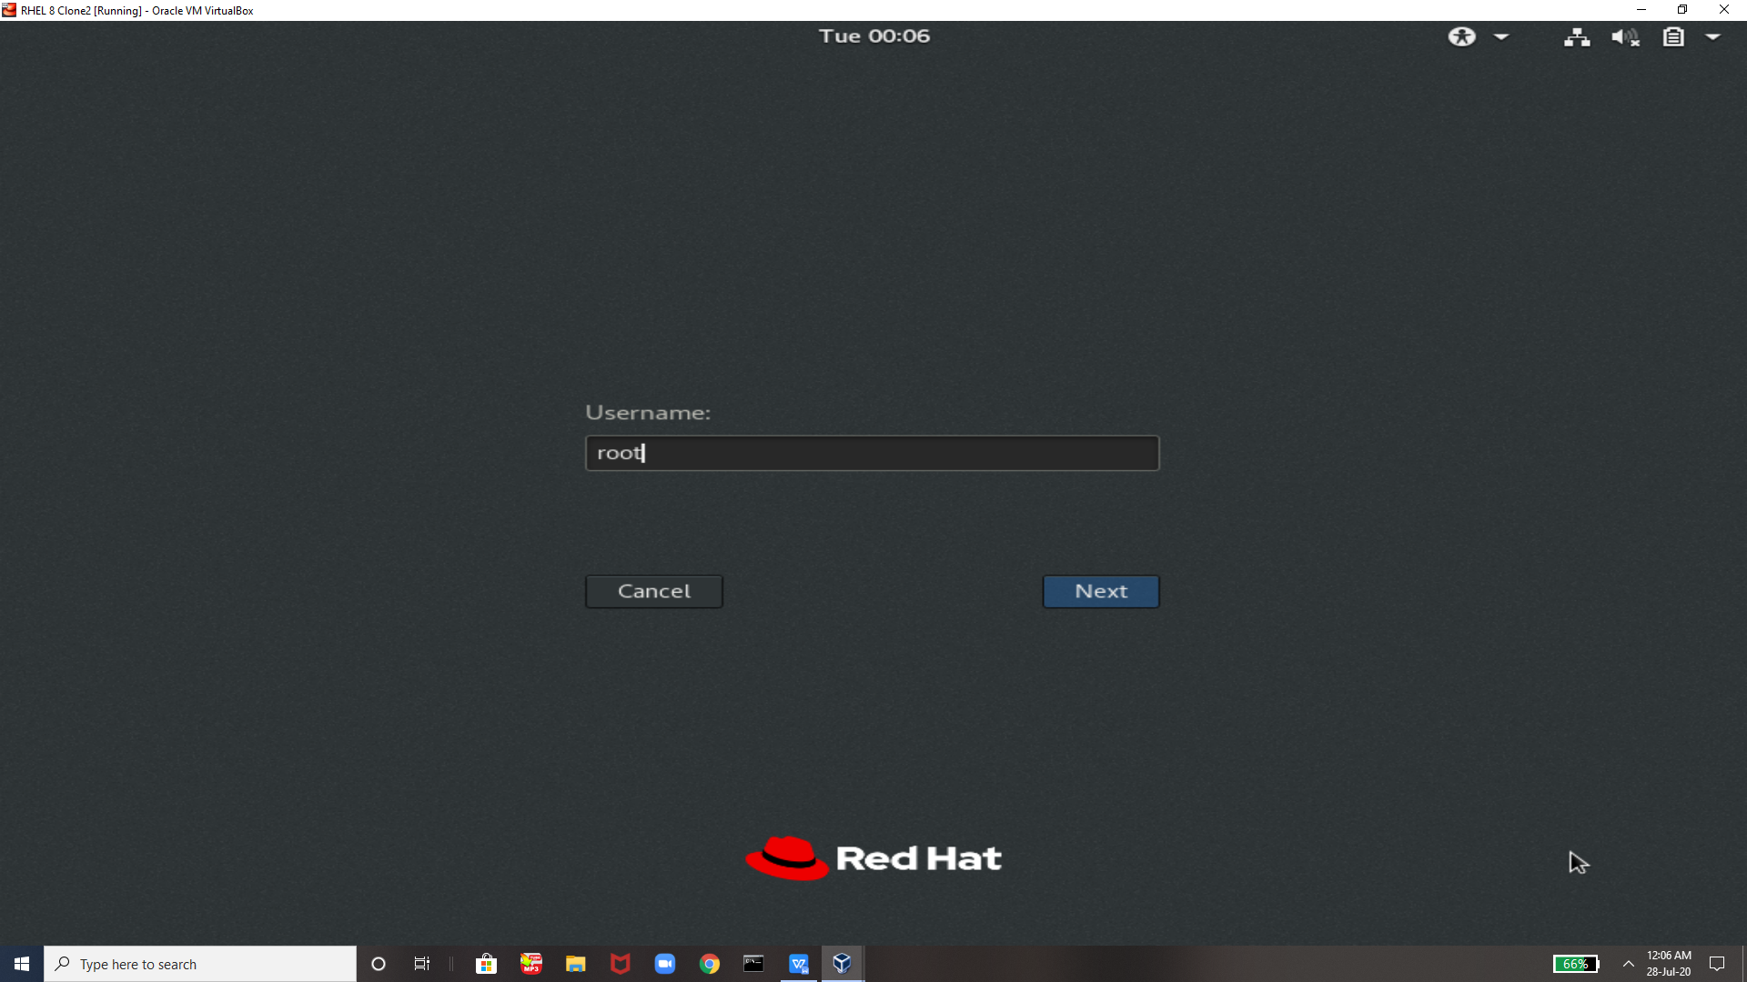

Checking and removing firefox from another system !!

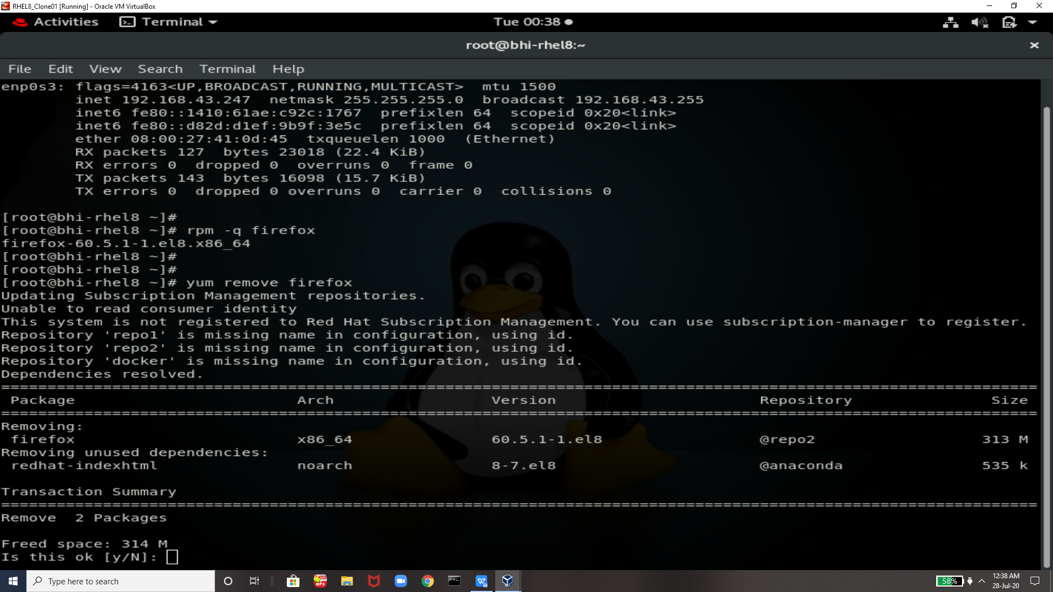

Can ping and ssh to our first system that is main systen !

In second system there is no firefox as we can see its completely removed

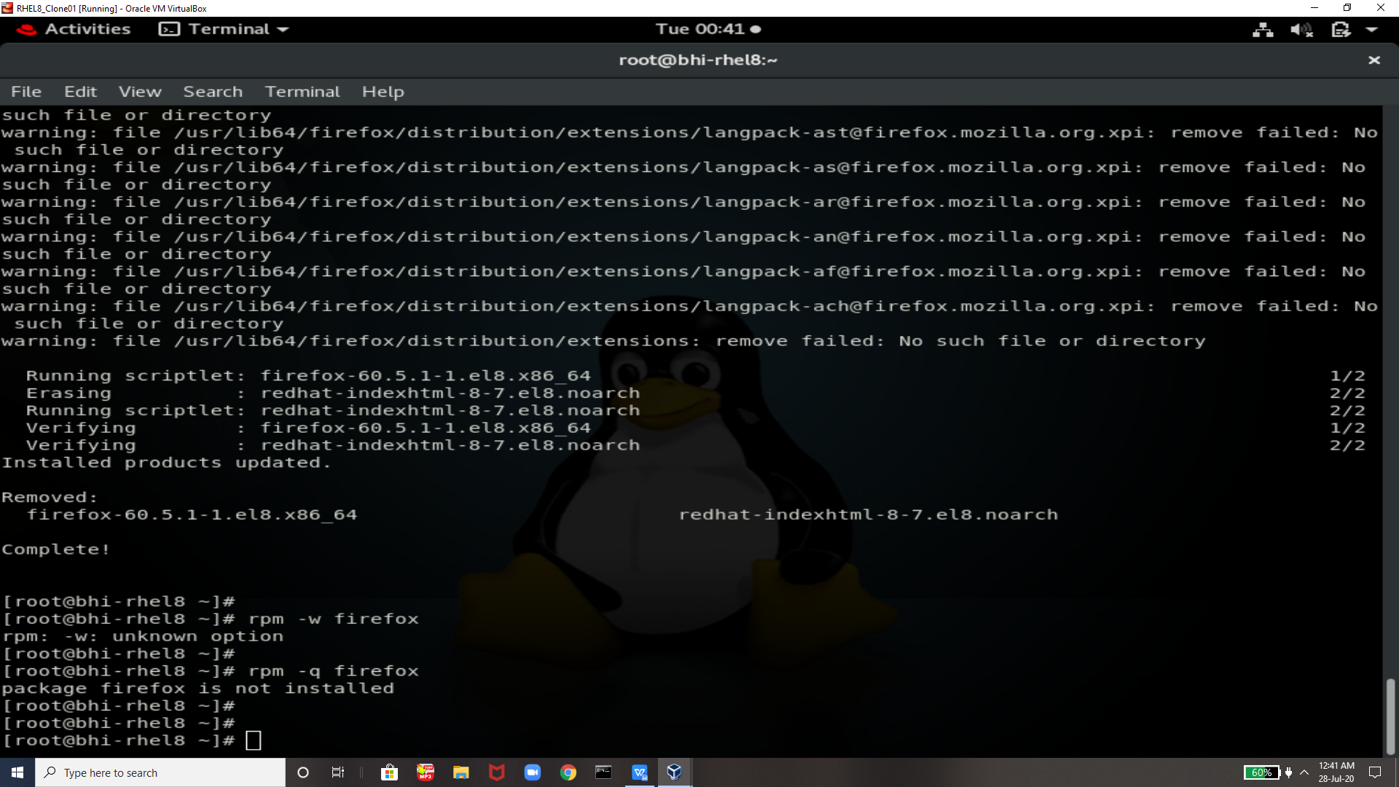

So know ansible will come and play its role !!

If someone does nt have epel-release download In their vn then this is how u can download it

Installing epel-release

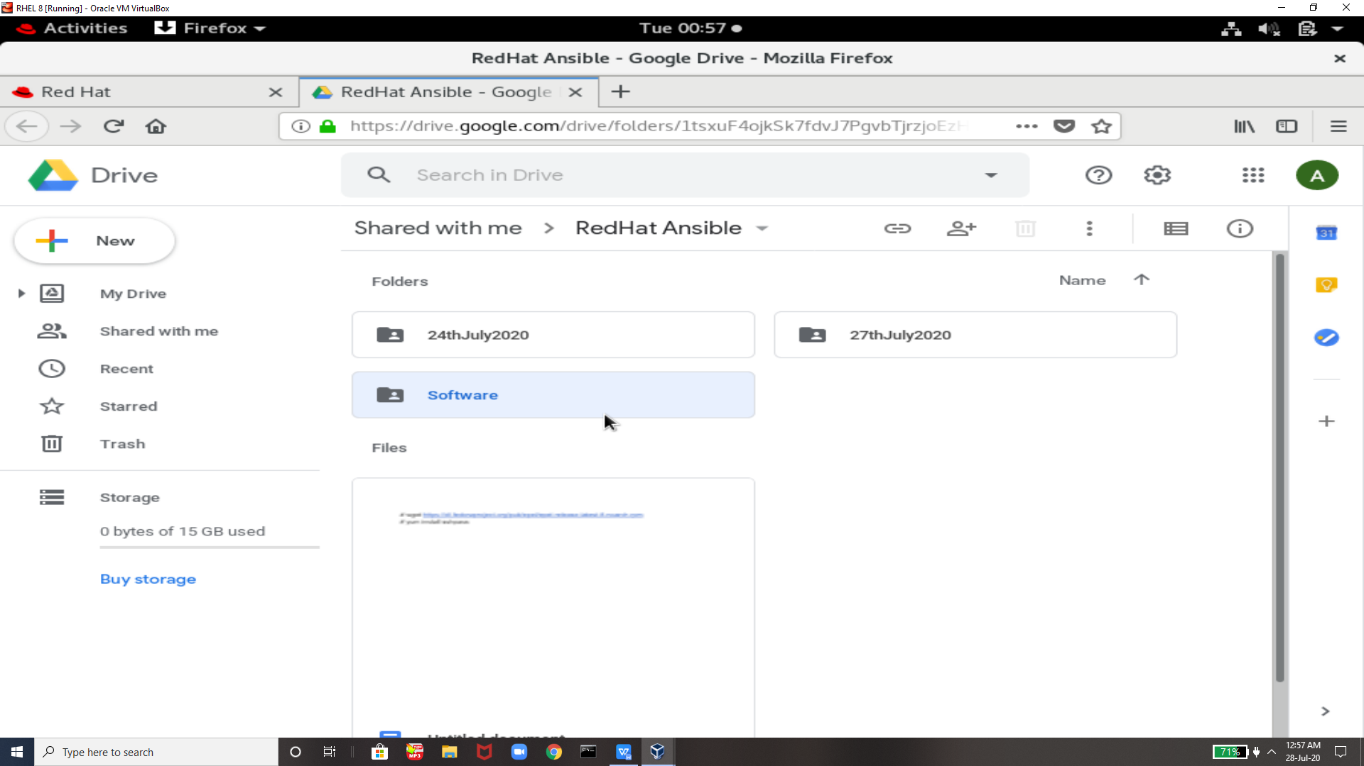

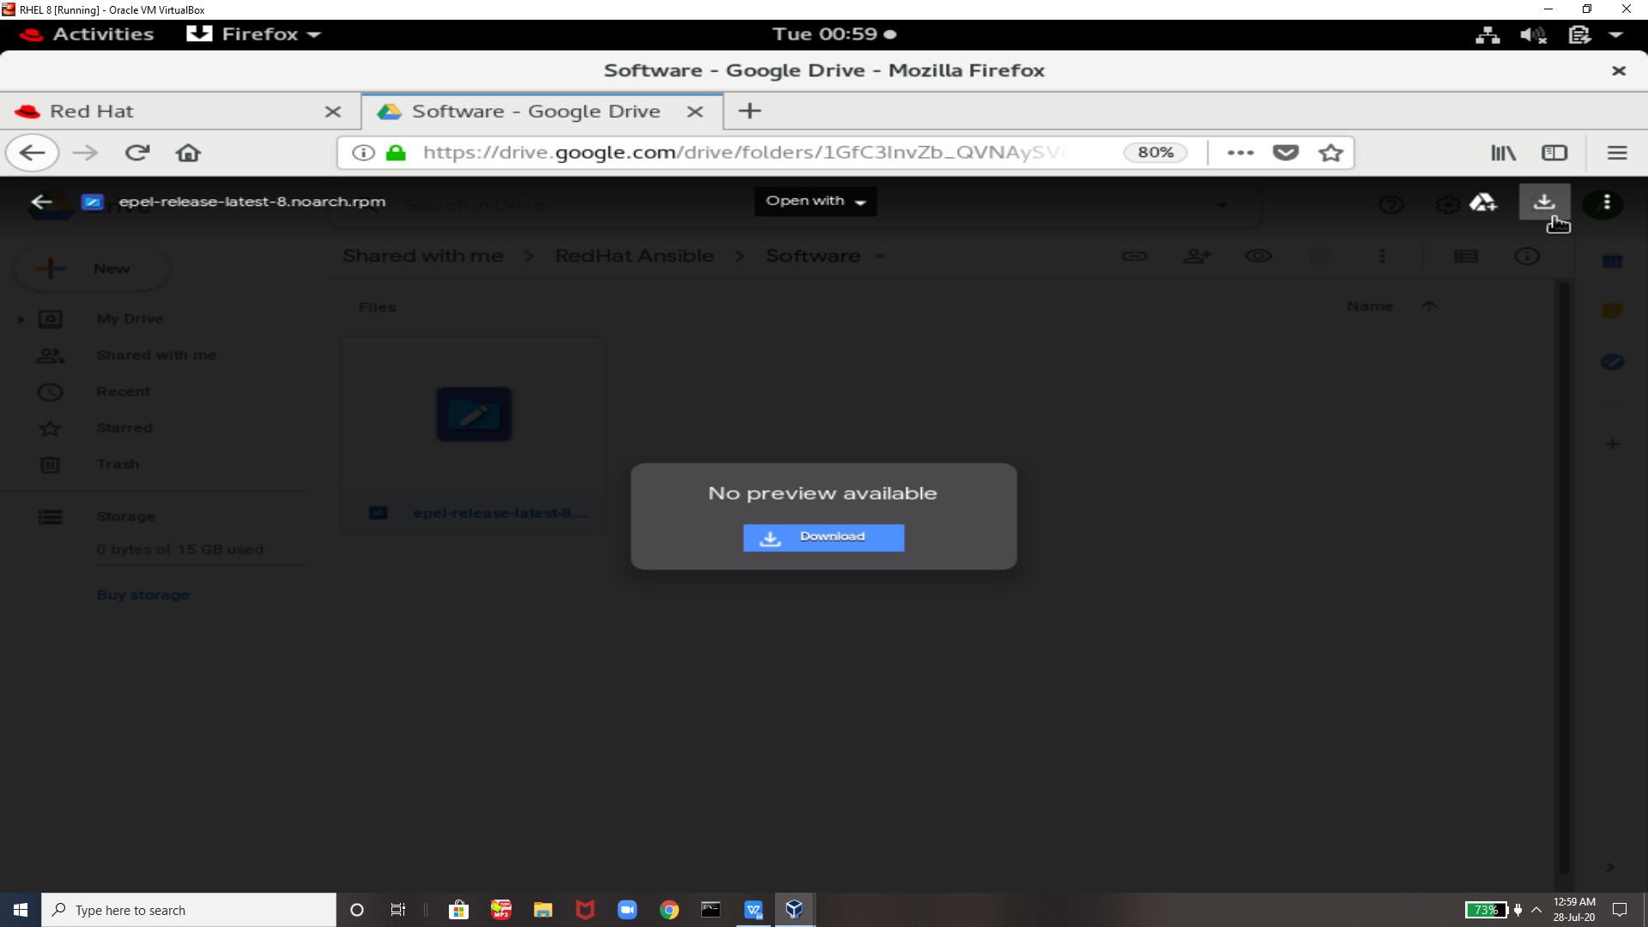

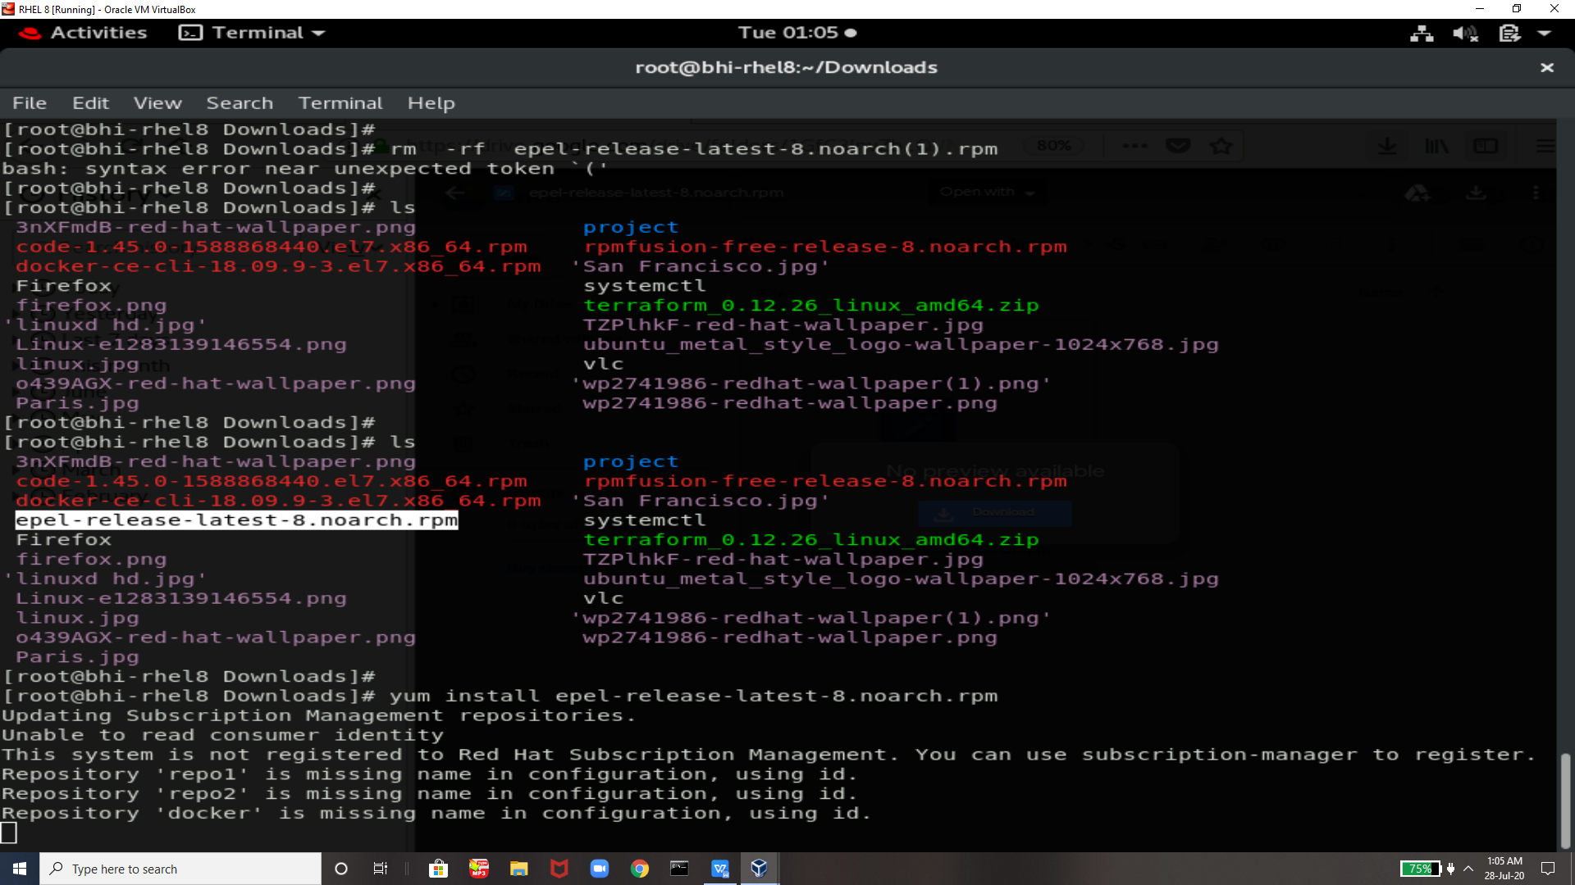

If anyOne Facing error like this shown in below image then

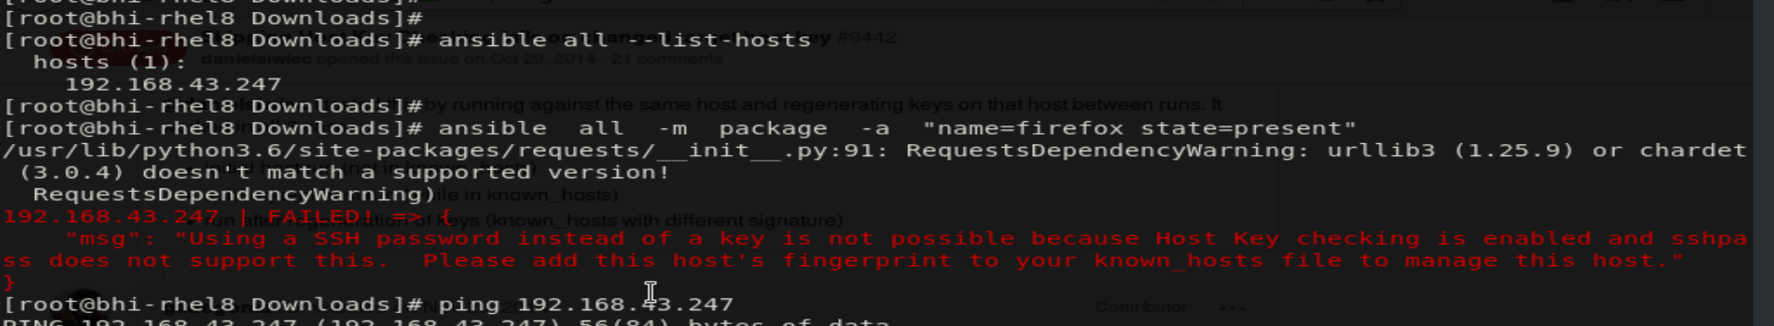

THen run this command **export ANSIBLE_HOST_KEY_CHECKING=False**

And then try again it will work



As u can see there is not any firefox in the system having ip 247 so now we will run one command from 178 ip system and ansible will do its work !!

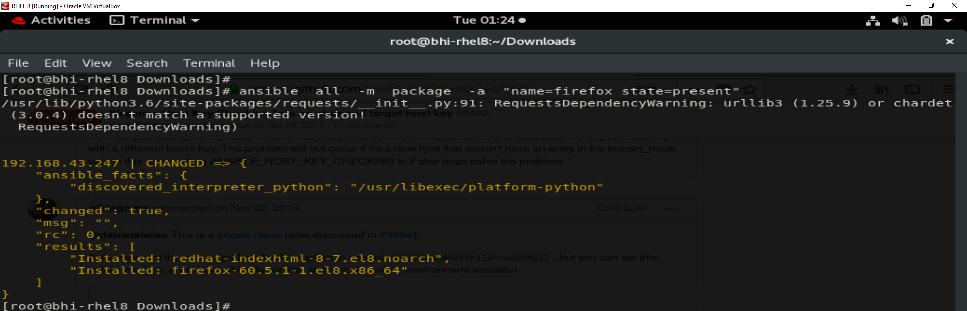

So it will download firefox from this systen having ip 178 to the systen having ip 247

And many other softwars and other things we can also download using ansible but for now I am showing u this only

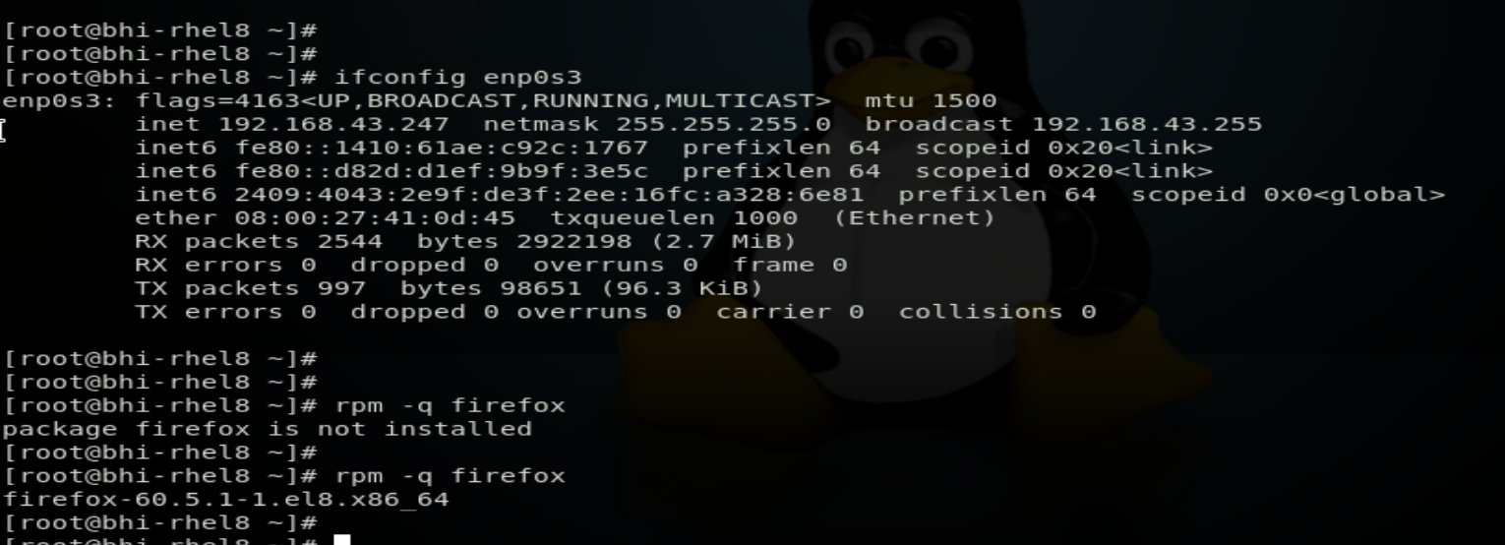

And now if we will run again the command of ansible it will say firefox already dowloaded

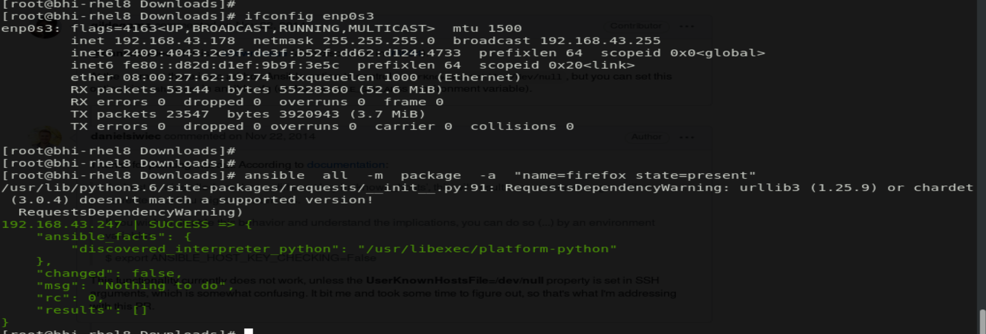

Thats all guys its all about how we can setup ansible in rhel 8



**Thanks to vimal sir fOr Teaching us this tools and technologies**

THanks EveryOne For ReaDing !!!

**Hope This will Help uHh all**